
HTU Course Number and Title : 10203380 - Computer Organization and Design
Course Tutor : Dr. Huthaifa Al-Omari
Assignment Title : Analysis and Design of Customized Computer System
Student Name : Ahmad Marwan AlMaghaireh
Student ID : 23110205
Academic Year : 2025-2026 Fall
Date : 17/01/2026
Contents
Q1 2
Q2 5
Q3 7
Q4 9
Q5 11
Q6 14
Q7 18
Q8 18
Q9 20
Q10 23
Q11 23
Q12 27
Q13 28
Q14 29
Q15 30

Q1
Basic Computer (BC)
The Basic Computer (BC) is a simple educational computer model introduced by Morris Mano to demonstrate the internal organization of a digital computer and the execution of instructions using the fetch–decode–execute cycle.
It uses a common bus system to transfer data between registers, memory, and the arithmetic logic unit.

The main Componnts of basic computer.
Memory Unite
Size: 4096 × 16 bits
Functione:
Store both program instructionse and data
Each memory location holds one 16-bit word.

Registers and CPU Components
Component | Size | Function
Address Register (AR) | 12 bit | Holds the address of the memory location to be accessed
Programe Counter (PC) | 12 bit | It Holds the addrss of the next instructione to be fetched
Data Regester (DR) | 16 bit | Holds data read from or written to memory
Accumuilator (AC) | 16 bit | Maine register for arithmetice and logic operations
Instruction Register (IR) | 16 bit | Holds the fetched instruction (opcode + address field)
Temporary Register (TR) | 16 bit | Stores temporary data during execution
Input Register (INPR) | 8 bits | Receives 8-bit data from input devices
Output Register (OUTR) | 8 bit | Holds 8-bit data to be sent to output devices
Arithmetic Logic Unit (ALU) | 16 bit | Performs arithmetic and logic operations
Common Bus | 16 bit | Transfers data between registers, memory, and ALU
Control Unit | — | Generates timing and control signals

Explanation of Key Components
Address Register (AR)
The AR is twelve bit wide because the memory has 4096 locationse (2¹²). It holds the addrss of the memmory location that will be accesed during fetch or execution.
Program Counter (PC)
The PC is also 12 bits wide and holds the address of the next instruction to be fetched. After each fetch, it automatically increments unless a branch instruction is executed.
Data Register (DR)
The DR is 16 bits wide to match the memory word size. It temporarily stores data read from memory or data to be written back to memory.
Accumulator (AC)
The AC is a 16-bit register used as the main processing register. It works directly with the ALU to perform arithmetic and logic operations.
Instruction Register (IR)
The IR is 16 bits wide and stores the currently fetched instruction. It contains:
- Opcode field (IR[15–12])
- Address field (IR[11–0])
Input and Output Registers
- INPR (8 bits): Receives input characters from input devices
- OUTR (8 bits): Holds output characters before sending them to output devices
Arithmetic Logic Unit (ALU)
The ALU is 16 bits wide and perform arithmetice (ADD, INC) and logic {AND;NOT} operation using data from AC and DR.
Control Unit
The control unit coordinates all system operations by generating control signals that manage the instruction cycle and data movement.
Common Bus System
The common bus is 16 bits wide and provides a shared communication path that allows only one register at a time to place data on the bus while multiple registers may receive data.

Basic Computer Organization Diagram (Conceptual)
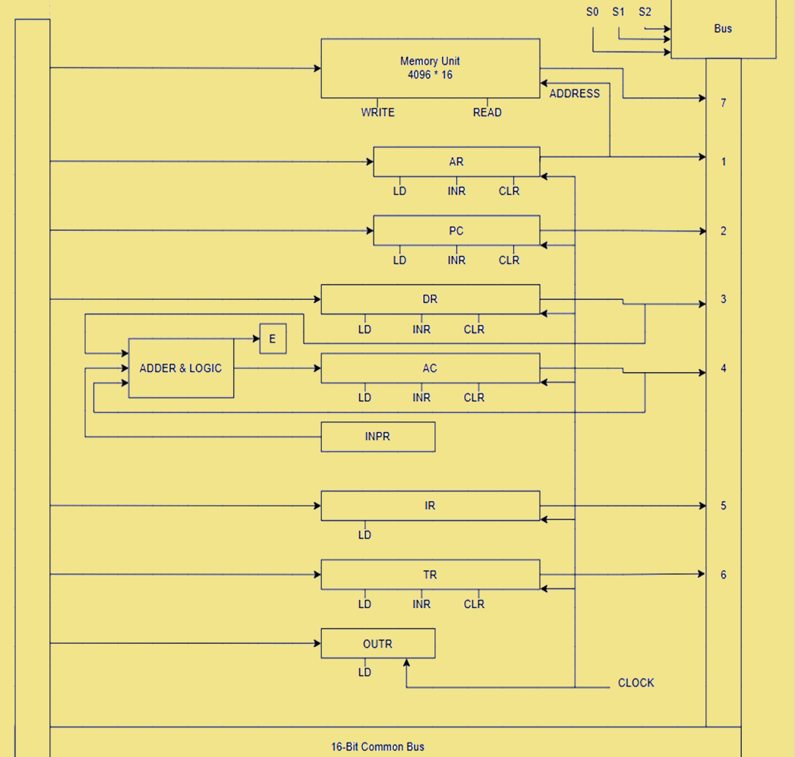

Q2

A) $f(W,X,Y,Z)=Σ(0,2,3,4,5,7,8,10,13,15)$
K-map (WX / YZ)

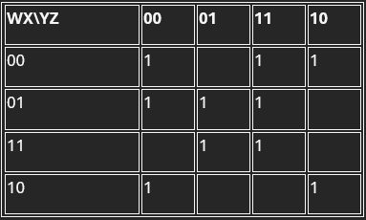
Simplified result
$$\boxed{f(W,X,Y,Z)=XZ+X^{'}Z^{'}+W^{'}X^{'}Y+W^{'}Y^{'}Z^{'}}$$
Logic diagram
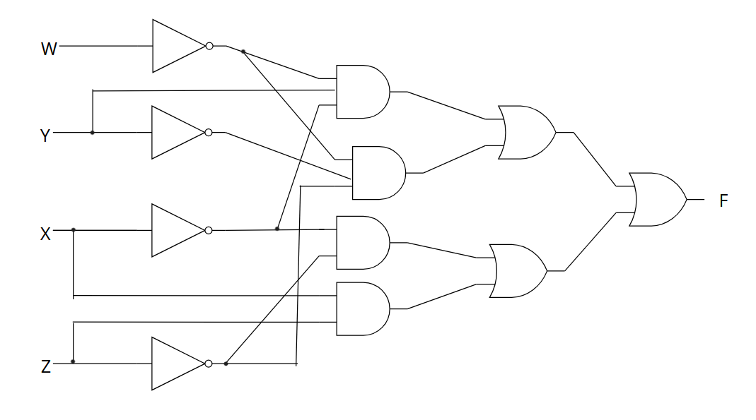
B) $f(W,X,Y,Z)=Σ(2,4,6,8,10,12)$
K-map (WX / YZ)
WX\YZ | 00 | 01 | 11 | 10
00 |  |  |  | 1
01 | 1 |  |  | 1
11 | 1
10 | 1 |  |  | 1
Simplified result
$$\boxed{f(W,X,Y,Z)=WX^{'}Z^{'}+XY^{'}Z^{'}+W^{'}YZ^{'}}$$
Logic diagram

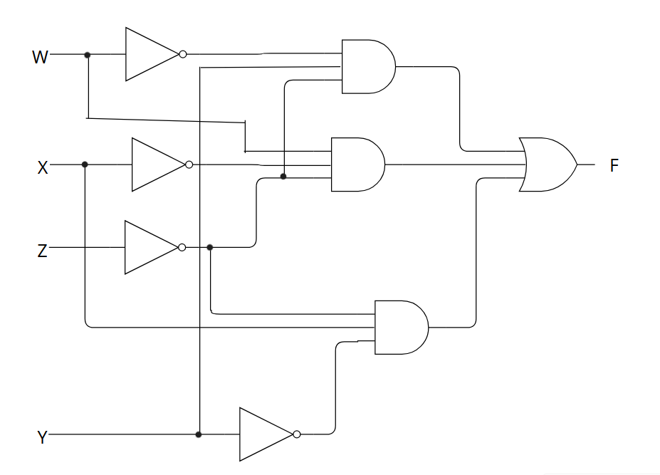

Q3
128K words , 32 bits each.
the binary instreuction code is storred in one word of memmory (32 bits).
The instruction has 4 parts:
- Indirct bit (I)
- Operatione code (Opcode)
- Regester code part {to detrmine one of 33 regesters}
- Address part (to access 128K words)

a) Number of bits in each part
Address Part
$$128K=128×1024=131072=2^{17}⇒\text{Address bits}=17$$
Address part = 17 bits
Register Code Part (33 registers)
We need enough bits to represent 33 choices:
- $2^{5}=32$(not enough)
- $2^{6}=64$(enough)
Register cod = 6 bit
Opcode bits
Total instreuction word = 32 bits:
$$32=1(\text{Indirect})+\text{Opcode}+6(\text{Register})+17(\text{Address}) \\ \text{Opcode}=32-(1+6+17)=32-24=8$$
Opcode = 8 bits

b) Instruction word format (32 bits)

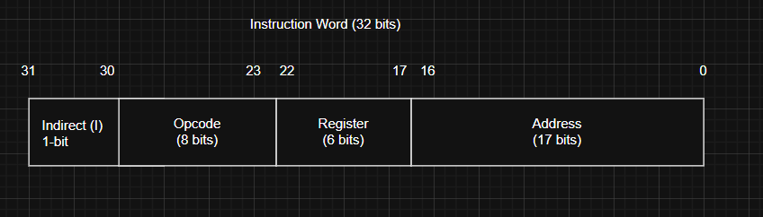
So the bit distribution is:
- Indirect bit = 1
- Opcode = 8
- Register = 6
- Address = 17
Total = 32 bits

c) Register sizes
Rule:
- Registers that store a full instruction/data word → 32 bits
- Registers that store a memory address → 17 bits
Register | Size
IR | 32 bits
TR | 32 bits
AR | 17 bits
AC | 32 bits
DR | 32 bits
PC | 17 bits

Q

4

Given
- Memory = 32K words ⇒ $32K=2^{15}$⇒ 15 address bits
- Word size = 16 bits
- Instruction stored in two words ⇒ instruction length = 32 bits
- Instruction parts: I bit (1) + opcode (unknown) + reg (4) + address (15)

(a) Number of opcode bits
Total instruction bits = 32.
$$\text{Opcode bits}=32-(I+Reg+Address) \\ =32-(1+4+15)=32-20=12$$
Opcode size = 12 bits

b)
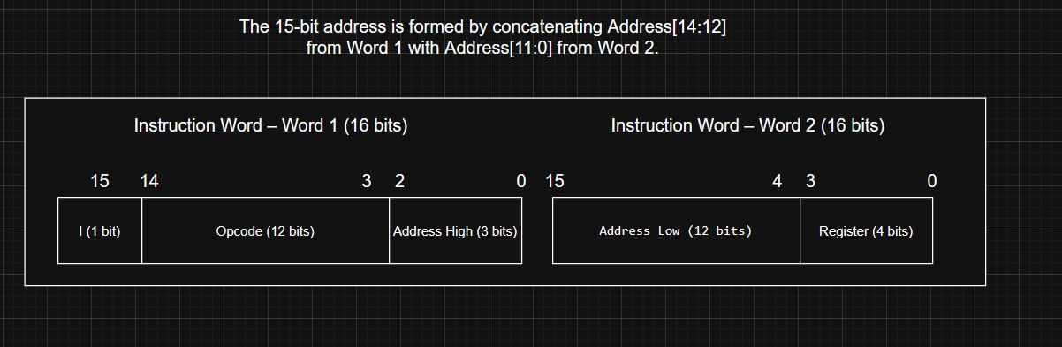

c)
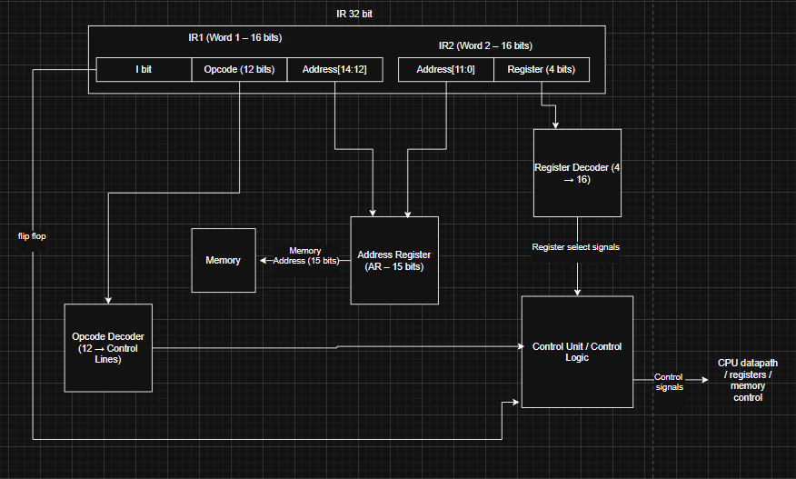

Q5
The Basic Computer (BC) supports a simple interrupt mechanism that allows external I/O devices to request CPU service when they are ready. This improves efficiency because the CPU does not need to continuously check (poll) I/O devices while executing the main program.
Interrupt handling in the BC depends mainly on:
- IEN (Interrupt Enable): enables/disables interrupts
- R (Interrupt Request flip-flop): indicates an interrupt is pending
- FGI (Input Flag): becomes 1 when an input device is ready
- FGO (Output Flag): becomes 1 when an output device is ready
When does an interrupt occur?
An interrupt is recognized at the end of the instruction cycle if:
- IEN = 1 {interrupt ennabled}, and
- FGI = 1 / FGO = 1 (an input or output device requests service).
If these conditions are satisfied, the control logic sets:
$$R←1$$
and the computer enters the interrupt cycle instead of fetching the next instruction.

Interrupt Cycle Micro-operations (RT0–RT2)
When R = 1, the BC executes the interrupt cycle using the following micro-operations:
RT0
$$AR←0,TR←PC$$
The adress regester is clearede to point to memory locatione 0, and the programe counter value (return address) is copiede to the temmporary regester.
RT1
$$M[AR]←TR,PC←0$$
The returns adress is stored in memmory locatione 0 (since AR = 0). Then the program counter is cleared.
RT2
$$PC←PC+1,IEN←0,R←0,SC←0$$
The PC is incremnted to become 1, interrupts are disabled to avoid nested interrupts, the interrupte requst flip-flop is cleared, and the sequenc countere is resete so the next cycl start normally.
After RT2, the next instructione is fetchede from memory address 1, which typically contains a branch insteruction (BUN) to the interrupte servic routin.
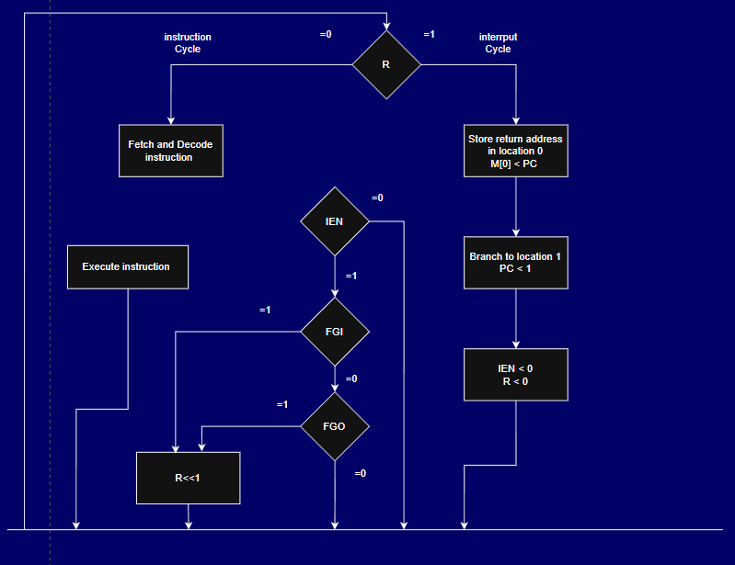

Numerical Example
Assume the CPU is executing an instruction located at memory address 120. After executing this instruction, the Programe Counter (PC) hold 121, which is the address of the next insteruction in the main program.
If an interrupt occurs while IEN = 1 and an I/O flag is set (FGI = 1 or FGO = 1), the BC performs the interrupt cycle and saves the return address:
$$M[0]←121$$
Then the BC loads:
$$PC←1$$
At memory location 1, there is typically an instruction such as:
$$BUN 1500$$
This causes the CPU to branch to the interrupt service routine starting at address 1500. After the interrupt routine finishes, the stored return address in memory location 0 is used to restore execution of the main program, and the program continues from address 121.
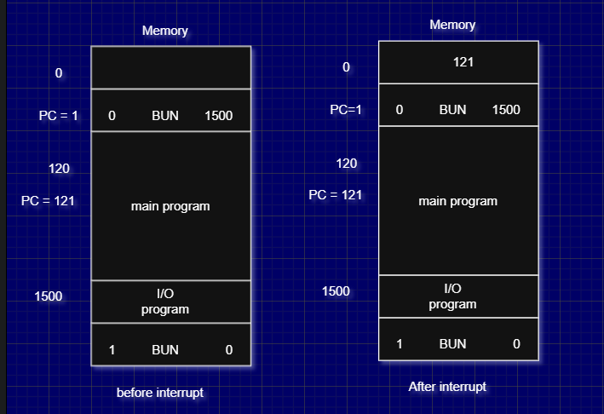

Q6
The ISZ (Increment and Skip if Zero) instruction is a memory-reference instruction in the Basice Computere. Its function is increment the content of a memory location specified by the effective address. If the incremented value becomes zero, the instruction causes the computer to skip the next instruction in sequence.
The ISZ instruction belongs to the memory-reference instruction group and corresponds to opcode D6.
The execution of the ISZ instruction is divided into three main phases: Fetch, Decode, and Execute. The complete sequence of micro-operations from T0 to T6 is described below.

1. Fetch and Decod Phas
These steps are common to all memory-reference instructions:
- T0:
$$AR←PC$$
The contents of the Program Counter are transferred to the Address Register.
- T1:
$$IR←M[AR],PC←PC+1$$
The instruction is fetched from memory and stored in the Instruction Register, and the Program Counter is incremented.
- T2:
$$D_{0},…,D_{7}←Decode IR(12\text{–}14),AR←IR(0\text{–}11),I←IR(15)$$
The opcode is decoded (D6 corresponds to ISZ), the address field is loaded into the Address Register, and the indirect addressing bit is stored in the I flip-flop.
- T3:
If I = 1, indirect addressing is used and the effective address is obtained by:
$$AR←M[AR]$$
If I = 0, direct addressing is used and no operation is performed during this step.

2. Execute Phase (ISZ – D6)
The execution phase performs the increment and conditional skip operation:
- D6T4:
$$DR←M[AR]$$
The operand stored at the effective memory address is loaded into the Data Register.
- D6T5:
$$DR←DR+1$$
The value in the Data Regster is incremented by 1.
- D6T6:
$$M[AR]←DR,\text{if }(DR=0)\text{ then }PC←PC+1,SC←0$$
The updatede valu is written back to memory. If the result is zero, the Program Counter is incrementd to skip the next instructione. Finally, the sequence countere is reset to begin the next instruction cycle.
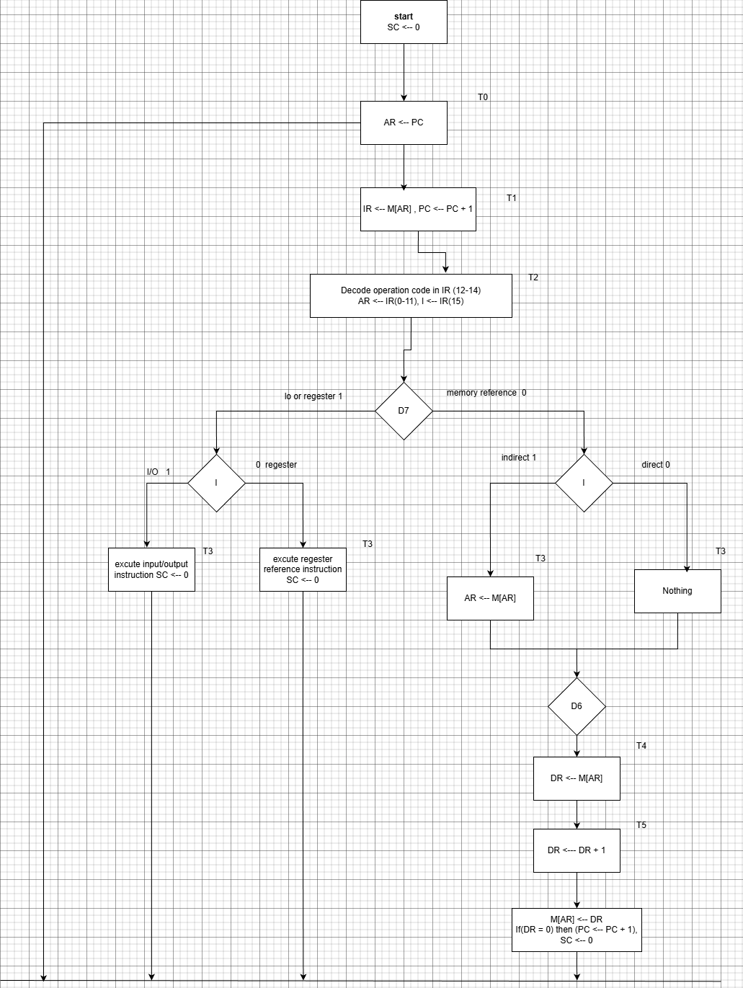

Q7

1) Source select (which register drives the bus) → S2 S1 S0
2) Destination select (which register loads from the bus) → D2 D1 D0 → decoder outputs L1..L7

1) Source Select Truth Table (MUX control)
This selects one register output to appear on BUS[5:0].

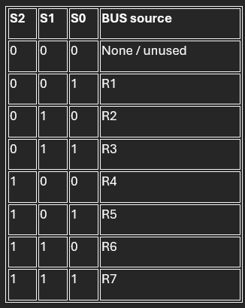
Meaning: if S=101, then BUS[5:0] = R5[5:0]

2) Destination Select Truth Table (Decoder + Load enables)
This selects one register to load from BUS[5:0] on the clock edge.
Assume decoder outputs are one-hot: only one Li is 1.

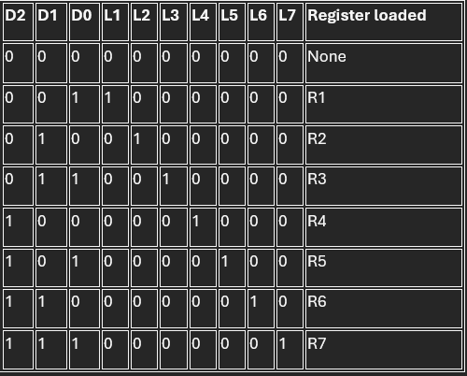
Meaning: if D=110, then L6=1 → on the next clock edge R6 ← BUS.

Example
To perform R5 ← R2:
Set source: S2S1S0 = 010 (BUS gets R2)
Set destination: D2D1D0 = 101 (R5 loads)
Apply clock edge → R5 ← BUS = R2

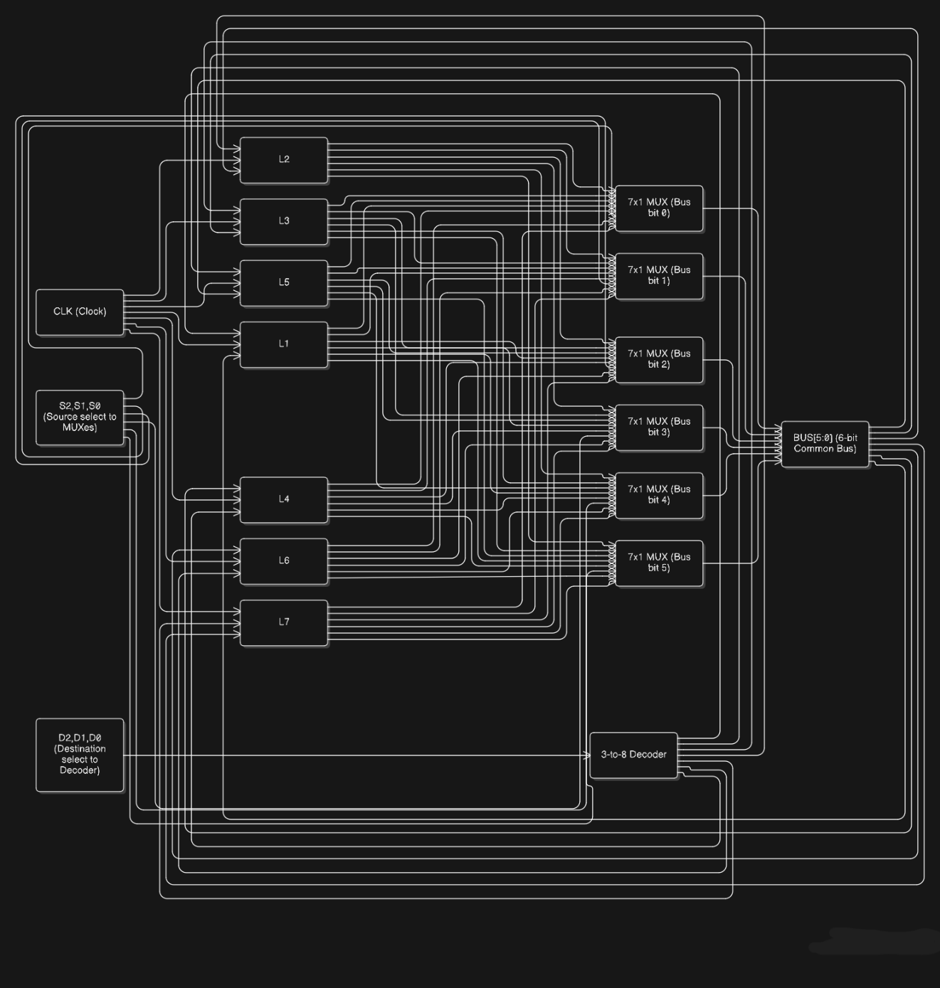

Q8

Given: Convert the hexadecimal number FAE739BD45 to its equivalent octal number.

(FAE739BD45)₁₆ to Binary
In hexadecmal, each digit = 4 binary bits:
Hex | Binary
F | 1111
A | 1010
E | 1110
7 | 0111
3 | 0011
9 | 1001
B | 1011
D | 1101
4 | 0100
5 | 0101
So:
$$\left(FAE739BD45)_{16}=(1111 1010 1110 0111 0011 1001 1011 1101 0100 0101)_{2}\right.$$

(FAE739BD45)₁₆ to Octal
We convert from binary to octal by grouping binary digits in sets of 3 from right to left.
Since we have 40 bits, we add two leading zeros to make the number of bits a multiple of 3:
Binary:
$$1111 1010 1110 0111 0011 1001 1011 1101 0100 0101$$
Add leading zeros:
$$00 1111 1010 1110 0111 0011 1001 1011 1101 0100 0101$$
Now group into 3-bit sets:
$$001 111 101 011 100 111 001 110 011 011 110 101 000 101$$
Convert each group:
Binary | Octal
001 | 1
111 | 7
101 | 5
011 | 3
100 | 4
111 | 7
001 | 1
110 | 6
011 | 3
011 | 3
110 | 6
101 | 5
000 | 0
101 | 5
Therefore:
$$\left(FAE739BD45)_{16}=(17534716336505)_{8}\right.$$
Final Answer: (17534716336505)₈

Q9
The range of 8-bit signed 2’s complement numbers is −128 to +127.

a) (+97) + (+120)
Positive numbers:
+97 in binary:
+97 = 01100001
+120 in binary:
+120 = 01111000
Binary addition:
01100001 (+97)
+ 01111000 (+120)
-----------
11011001
The result is 11011001.
The most significant bit (MSB) is 1, which indicates a negative number, while both operands were positive.
The expected decimal result is:
$$97+120=217$$
Since 217 exceeds the maximum value (+127) that can be represented using 8-bit signed numbers, overflow occurs due to sign reversal.

b) (−97) + (−120)
Negative numbers (2’s complement form):
+97 = 01100001
2’s complement of +97:
10011111 = −97
+120 = 01111000
2’s complement of +120:
10001000 = −120
Binary addition:
10011111 (−97)
+ 10001000 (−120)
-----------
1 00100111
After discarding the carry-out bit, the result is:
00100111
The MSB is 0, indicating a positive number, while both operands were negative.
The expected decimal result is:
$$-97+(-120)=-217$$
Since −217 is outside the valid range (−128 to +127), overflow occurs due to sign reversal.

c) (+97) + (−120)
Binary representations:
+97:
01100001
−120 (2’s complement of +120):
10001000
Binary addition:
01100001 (+97)
+ 10001000 (−120)
-----------
11101001
The result is 11101001.
Converting this back to decimal:
- 11101001 → 2’s complement → −23
Verification:
$$97+(-120)=-23$$
Since the operands have different signs, and the result lies within the valid range, no overflow occurs.

d) (−97) + (+120)
Binary representations:
−97:
10011111
+120:
01111000
Binary addition:
10011111 (−97)
+ 01111000 (+120)
-----------
1 00010111
After discarding the carry-out bit, the result is:
00010111
This corresponds to +23 in decimal.
Verification:
$$-97+120=23$$
Since the operands have different signs and the result is within range, no overflow occurs.

Summary
Operation | Result (8-bit) | Decimal Result | Overflow
(+97) + (+120) | 11011001 | 217 | Yes
(−97) + (−120) | 00100111 | −217 | Yes
(+97) + (−120) | 11101001 | −23 | No
(−97) + (+120) | 00010111 | 23 | No

Q10
dfg

Q11
Expression (infix)
$$\frac{\left(\frac{A}{B}\right)⋅\left(\frac{C}{D}+\frac{E}{F}-(G-H)\right)}{W+\left(\frac{X}{Y}\right)}$$

(a) Infix → Reverse Polish Notation (RPN)
I’ll write it in the same comma-separated style your friend used:
RPN:
*A, B, /, C, D, /, E, F, /, +, G, H, -, -, , W, X, Y, /, +, /
(Equivalent spaced form: A B / C D / E F / + G H - - * W X Y / + /)

(b) Stack operations (text form)
Rule:
- If it’s an operand (A, B, …) → Push
- If it’s an operator (+, −, *, /) → Pop op2, Pop op1, compute (op1 operator op2), then Push result
Start with empty stack [].
- Read A → Push(A)
Stack: [A]
- Read B → Push(B)
Stack: [A, B]
- Read / → Pop(B), Pop(A), Push(A/B)
Stack: [A/B]
- Read C → Push(C)
Stack: [A/B, C]
- Read D → Push(D)
Stack: [A/B, C, D]
- Read / → Pop(D), Pop(C), Push(C/D)
Stack: [A/B, C/D]
- Read E → Push(E)
Stack: [A/B, C/D, E]
- Read F → Push(F)
Stack: [A/B, C/D, E, F]
- Read / → Pop(F), Pop(E), Push(E/F)
Stack: [A/B, C/D, E/F]
- Read + → Pop(E/F), Pop(C/D), Push((C/D)+(E/F))
Stack: [A/B, (C/D + E/F)]
- Read G → Push(G)
Stack: [A/B, (C/D + E/F), G]
- Read H → Push(H)
Stack: [A/B, (C/D + E/F), G, H]
- Read - → Pop(H), Pop(G), Push(G−H)
Stack: [A/B, (C/D + E/F), (G−H)]
- Read - → Pop(G−H), Pop(C/D + E/F), Push((C/D + E/F) − (G−H))
Stack: [A/B, ((C/D + E/F) − (G−H))]
- Read * → Pop(((C/D + E/F) − (G−H))), Pop(A/B), Push((A/B) * ((C/D + E/F) − (G−H)))
Stack: [(A/B) * ((C/D + E/F) − (G−H))]
- Read W → Push(W)
Stack: [(A/B) * ((C/D + E/F) − (G−H)), W]
- Read X → Push(X)
Stack: [(A/B) * ((C/D + E/F) − (G−H)), W, X]
- Read Y → Push(Y)
Stack: [(A/B) * ((C/D + E/F) − (G−H)), W, X, Y]
- Read / → Pop(Y), Pop(X), Push(X/Y)
Stack: [(A/B) * ((C/D + E/F) − (G−H)), W, (X/Y)]
- Read + → Pop(X/Y), Pop(W), Push(W + (X/Y))
Stack: [(A/B) * ((C/D + E/F) − (G−H)), (W + X/Y)]
- Read / → Pop(W + X/Y), Pop((A/B) * ((C/D + E/F) − (G−H))), Push( [(A/B) * ((C/D + E/F) − (G−H))] / [W + (X/Y)] )
Stack: [ Final Result ]
Final value on stack is the value of the original infix expression.
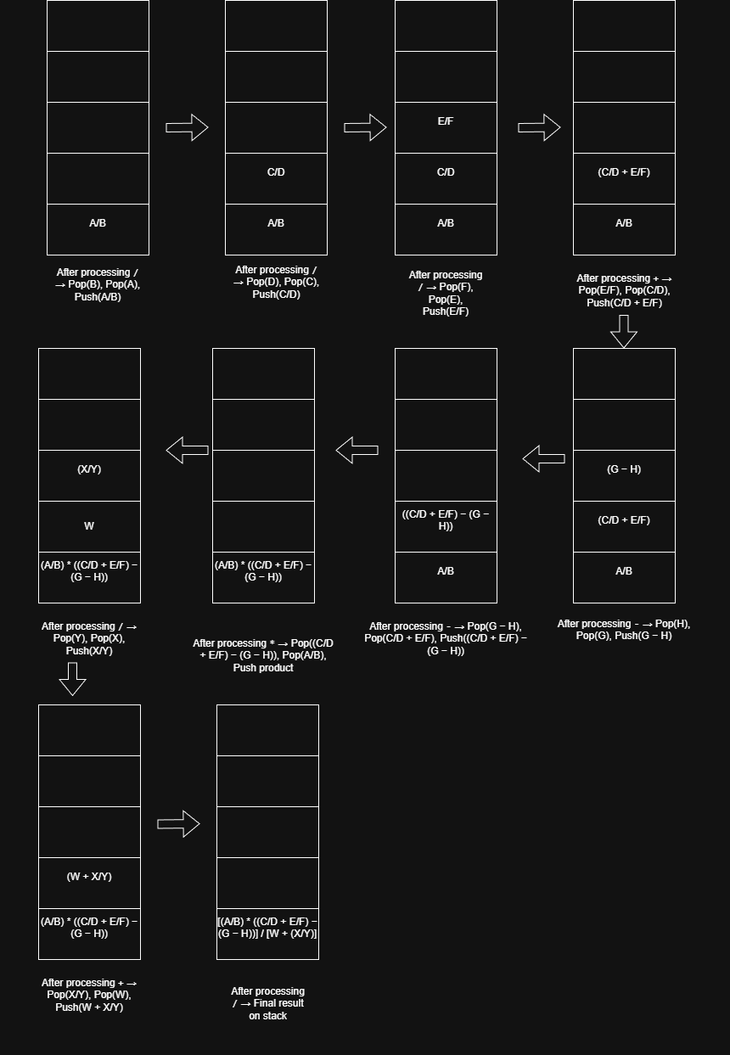

Q12
Given
(a) RPN:
A B C D E F G / - + * - *
(b) RPN:
T U V W X Y Z * / * - / +

(a): RPN → Infix
Step-by-step structure (brief logic)
- F G / → (F/G)
- E - → (E − F/G)
- D + → (D + (E − F/G))
- C * → C × (D + (E − F/G))
- B - → B − [C × (D + (E − F/G))]
- A * → A × (B − [C × (D + (E − F/G))])

infix expression

$$\boxed{A×(B-(C×(D+(E-(F/G)))))}$$

Question 12(b): RPN → Infix
Step-by-step structure (brief logic)
- Y Z * → (Y × Z)
- X / → X / (Y × Z)
- W * → W × (X / (Y × Z))
- V - → V − [W × (X / (Y × Z))]
- U / → U / (V − [W × (X / (Y × Z))])
- T + → T + {U / (V − [W × (X / (Y × Z))])}

infix expression
$$\boxed{T+\frac{U}{\left(V-(W×(X/(Y×Z)))\right)}}$$

Q13

Given:
- Non-pipeline system time per task: tn = 50 ns
- Pipeline system:
  - Number of segments: k = 6
  - Clock cycle time: tp = 8 ns
- Number of tasks: n = 80

a) Time required by the non-pipeline system
In a non-pipeline system, tasks are processed sequentially.
$$T_{1}=n×t_{n} \\ T_{1}=80×50\text{ ns} \\ \boxed{T_{1}=4000\text{ ns}}$$

b) Time required by the pipeline system
For a pipeline with k stages, total time is:
$$T_{k}=(k+n-1)×t_{p} \\ T_{k}=(6+80-1)×8\text{ ns} \\ T_{k}=85×8 \\ \boxed{T_{k}=680\text{ ns}}$$

c) Speedup ratio of the pipeline
Speedup is defined as:
$$S_{k}=\frac{T_{1}}{T_{k}} \\ S_{k}=\frac{4000}{680} \\ \boxed{S_{k}≈5.88}$$

Final Answers (clean summary)
- Non-pipeline time: 4000 ns
- Pipeline time: 680 ns
- Speedup ratio: ≈ 5.88

Q14

(a) RTL micro-operations + dataflow diagram description
Pipeline segmentation
- Stage 1: Divide $X/Y$
- Stage 2: Divide $W/Z$
- Stage 3: Subtract the two quotients
Because Stage 2 needs $W_{i},Z_{i}$for the same input that went through Stage 1, we must delay $W,Z$through pipeline registers.
RTL (using pipeline registers between stages)
Let the pipeline registers be $R1,R2,R3$(these are pipeline registers, not the “i=1..7” sets).
At each clock edge:
Input latch (into R1):
- R1.X ← Xi
- R1.Y ← Yi
- R1.W ← Wi
- R1.Z ← Zi
Stage 1 (Division 1: X/Y) + forwarding W,Z
- R2.Qx ← R1.X / R1.Y
- R2.W ← R1.W
- R2.Z ← R1.Z
Stage 2 (Division 2: W/Z) + forwarding Qx
- R3.Qw ← R2.W / R2.Z
- R3.Qx ← R2.Qx
Stage 3 (Subtraction)
- Fout ← R3.Qx − R3.Qw
That RTL is the key: compute Qx early, carry W/Z forward, compute Qw next, then subtract.

(b) Gantt-style timeline (7 input sets)
Let input sets be $i=1..7$.
Stages: S1 (X/Y), S2 (W/Z), S3 (Subtract)
Each cell shows which input set is in that stage during that clock.
Clock | S1: X/Y | S2: W/Z | S3: Sub
1 | i1 | – | –
2 | i2 | i1 | –
3 | i3 | i2 | i1
4 | i4 | i3 | i2
5 | i5 | i4 | i3
6 | i6 | i5 | i4
7 | i7 | i6 | i5
8 | – | i7 | i6
9 | – | – | i7
First output appears at clock 3, then one output per clock until done.

(c) Total execution time
Let:
- $n=7$input sets
- $k=3$pipeline stages
- clock period = $T_{clk}$
Non-pipelined execution
Each input set needs 3 sequential cycles:
$$T_{nonpipe}=n⋅k⋅T_{clk}=7⋅3⋅T_{clk}=21T_{clk}$$
So 21 cycles.
Pipelined execution
Pipeline total cycles:
$$\text{cycles}=k+(n-1)=3+6=9 \\ T_{pipe}=9T_{clk}$$
So 9 cycles.

(d) Speedup
$$\text{Speedup}=\frac{T_{nonpipe}}{T_{pipe}}=\frac{21T_{clk}}{9T_{clk}}=\frac{21}{9}=2.333...$$
Speedup ≈ 2.33×

Q15
RISC and CISC Architectures Research Study.
Introduction

Computer architecture determines the manner in which a processor is executed and it communicates with software. Instruction set architecture (ISA) is one of the most significant elements in the computer architecture. The major two philosophy of ISAs are Reduced Instruction Set Computer (RISC ) architecture and the Complex instrucition set computer (CISC). architecture. The two methods vary with regards to the complexity of instruction, the implementation plan and hardware structure. The properties, strengths, and weaknesses of RISC and CISC architecture are crucial to the analysis of contemporary computer system and its performance (Hennessy and Patterson, 2019).

Reduced Instruction Set Computer (RISC)

Reduced Instruction Set Computer Reduced Instruction Set Computer (RISC) architecture is built on the concept of simplifying the instruction set to enhance efficiency in the execution as well as the performance of the hardware. The RISC processors are normally small in number and are based on simple, fixed-length instructions which can be executed by a single clock cycle. One distinguishing feature of RISC architecture is the load-store design, in which only load and store instructions operate on memory, and arithmetic and logical operations are done on registers only. This method minimizes the delays on the memory access and enables quicker processing of instructions. General-purpose registers are also numerous in RISC architectures and allow reducing the number of memory operations and this leads to the general performance (Hennessy and Patterson, 2019).

RISC architecture is optimally pipelined and this is one of its key strengths. Due to simple instructions and standard format the instructions are easily decoded and more than one instruction can be run at the same time on the various stages of the pipeline. This leads to an increased instruction throughput and performance. Furthermore, RISC processors can be more power-efficient because of their less complicated control logic, thus being suitable to mobile, embedded, and energy-intense devices like smartphones and IoT systems (ARM Ltd., 2022).

Nevertheless, there exist certain drawbacks of the RISC architecture. Given that complex operations have to be decomposed into many simple instructions, it is possible that more instructions are needed to execute a process. This may cause some applications to increase the size of their code. Moreover, the performance of RISC is based on the sophisticated compiler optimization strategies to effectively schedule the instructions and successful utilization of registers. The advantages of RISC architecture can not be quite achieved without a good compiler.

Complex Instruction Set Computer (CISC)

Complex Instruction Set Computer (CISC) architecture is different, as it offers a large and varied number of instructions that can be used to perform the complex tasks. CISC processors frequently have numerous addressing modes and variable length instructions, making a single instruction potentially do many low level operations like accessing a memory and doing arithmetic calculations simultaneously. Traditionally, CISC the architectural designs were created in such a way that they minimized instructions per program and made assembly programming simpler (Patterson and Hennessy, 2017).

The smaller program size is one of the greatest benefits of CISC architecture. Due to the ability of complex instructions to substitute numerous simpler instructions, the total number of instructions in programs can reduce, resulting in smaller code. Strong backward compatibility is also a characteristic of CISC architectures. One famous case study is the x86 architecture which has ensured that the older software is compatible with more modern processors without modification over several decades (Intel Corporation, 2023).

Although these are the benefits, CISC architecture has significant weaknesses. The excessive number of instructions, address modes, makes the decoding instructions and control logic more complex. Pipelining is harder with variable-length instructions because the boundaries of instructions are not determinable. To overcome these issues, modern CISC processors internally interpret complex instructions in simpler micro-operations which are implemented in a RISC-like fashion. This raises the performance but also adds complexity to processor design (Hennessy and Patterson, 2019).

Comparison of RISC and CISC Architectures.

With recent computer architectures, RISC and CISC architectures are not so distinct as they were in early designs. Most modern processors are a blend of the two methods. As an example, the use of simplified micro-operations such as those found in RISC instructions is internally used by CISC processors like x86 systems and the use of such advanced techniques as out-of-order execution, branch prediction, and speculative execution are found in RISC processors. Consequently, microarchitectural characteristics affect the overall system performance more than the instruction set philosophy does.

However, the basic dissimilarities between RISC and CISC are also significant. RISC architectures focus on simplicity, regularity and pipeline efficiency and this tends to lead to superior power efficiency and predictable performance. By contrast, CISC architectures concentrate on richness of instruction, small programs and backward compatibility, particularly in desktop and server systems. The decision to use RISC or CISC will be based on application needs, power, performance objectives, and software ecosystems.

Conclusion

RISC and CISC architectures are two different schools of thought of the design of a processor which have their advantages and disadvantages. The simplicity of instructions, pipelining and low power consumption are top priorities of RISC architecture making it appropriate in energy efficient and high-performance systems. CISC architecture focuses on complex instructions and compactness of code with high software compatibility and flexibility. The demarcations between RISC and CISC in contemporary processors are less clear with architects adopting the best methods of both to create the best. This knowledge of these architectural philosophies is still critical in the analysis and design of the modern computing systems.

References
ARM Ltd. (2022) ARM Architecture Reference Manual. Cambridge: ARM Limited.
Hennessy, J.L. and Patterson, D.A. (2019) Computer Architecture: A Quantitative Approach. 6th edn. San Francisco: Morgan Kaufmann.
Intel Corporation (2023) Intel® 64 and IA-32 Architectures Software Developer’s Manual. Santa Clara, CA: Intel Corporation.
Patterson, D.A. and Hennessy, J.L. (2017) Computer Organization and Design: The Hardware/Software Interface. 5th edn. San Francisco: Morgan Kaufmann.
IEEE Computer Society (2020) Processor Architecture Trends. IEEE Press.

